Luis Guilherme Barros Rosa

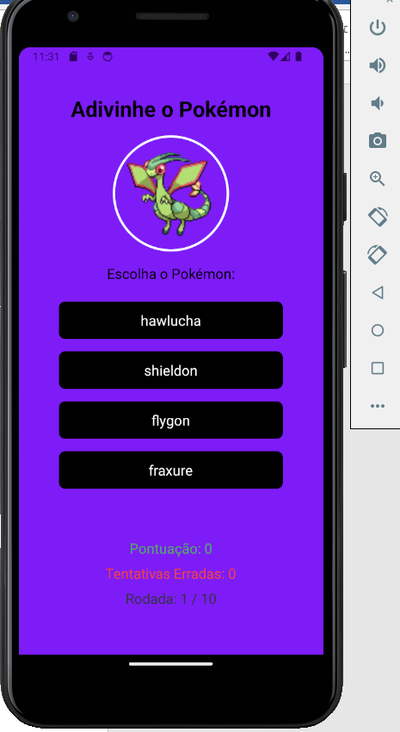

https://github.com/Lguilherme22/pokeandrei